|  |  |  |  |  |  |
| --- | --- | --- | --- | --- | --- |
| Species | Life Stage | Best Model | ΔMSE | ΔAIC | Deviance Explained |
| Alaska Plaice | Egg | $$\left(Log\left(Catch per 10m^{2}\right)+1\right)=factor\left(year\right)\sim s\left(doy\right)+s\left(bottom depth, k=5\right)+g\left(longitude, latitude, by=threshold regional SST\right)+ e_{doy,year,\left(lon,lat\right)}$$ | 0.149 | 463.75 | 75% |
| Larvae | $$\left(Log\left(Catch per 10m^{2}\right)+1\right)=factor\left(year\right)\sim s\left(doy,k=5\right)+s\left(bottom depth\right) + g\left(salinity, temperature\right)+e_{doy, year,(salinity,temperature)}$$ | 0.151 | 403.40 | 82.9% |
| Rex Sole | Egg | $$\left(Log\left(Catch per 10m^{2}\right)+1\right)=factor\left(year\right)\sim s\left(doy\right)+s\left(bottom depth, k=5\right)+g\left(longitude, latitude, by=threshold regional SST\right)+ e_{doy,year,\left(lon,lat\right)}$$ | 0.171 | 708.68 | 61.3% |
| Larvae | $$\left(Log\left(Catch per 10m^{2}\right)+1\right)=factor\left(year\right)\sim s\left(doy,k=5\right)+s\left(bottom depth\right) + g\left(salinity, temperature\right)+e_{doy, year,(salinity,temperature)}$$ | 0.052 | 113.18 | 17.3% |
| Walleye Pollock | Egg | (Log(Catch per 10m2)+1) = *factor*(year) + *s*(doy) + *s*(bottom depth, k=5) + *g*(longitude, latitude, by = threshold regional SST) + *e*doy,year,(lon,lat) | 0.133 | 591.2 | 58.1% |
| Larvae | $$\left(Log\left(Catch per 10m^{2}\right)+1\right)=factor\left(year\right)\sim s\left(doy,k=5\right)+s\left(bottom depth\right) + g\left(salinity, temperature\right)+e_{doy, year,(salinity,temperature)}$$ | 0.144 | 578.1 | 71.9% |
| Yellowfin Sole | Egg | (Log(Catch per 10m2)+1) = *factor*(year) + *s*(doy) + *s*(bottom depth, k=5) + *g*(doy, by = threshold regional SST) + *e*doy,year,(lon,lat) | 0.111 | 507.03 | 68.7% |
| Larvae | $$\left(Log\left(Catch per 10m^{2}\right)+1\right)=factor\left(year\right)\sim s\left(doy,k=5\right)+s\left(bottom depth\right) + g\left(salinity, temperature\right)+e_{doy, year,(salinity,temperature)}$$ | 0.194 | 569.00 | 83.8% |
| Flathead Sole | Egg | (Log(Catch per 10m2)+1) = *factor*(year) + *s*(doy) + *s*(bottom depth, k=5) + *g*(doy, by = threshold regional SST) + *e*doy,year,(lon,lat) | 0.179 | 901.13 | 76.2% |
|  | Larvae | $$\left(Log\left(Catch per 10m^{2}\right)+1\right)=factor\left(year\right)\sim s\left(doy,k=5\right)+s\left(bottom depth\right) + g\left(salinity, temperature\right)+e_{doy, year,(salinity,temperature)}$$ | 0.149 | 381.28 | 70.9% |
| Pacific Cod | Larvae | $$\left(Log\left(Catch per 10m^{2}\right)+1\right)=factor\left(year\right)\sim s\left(doy,k=5\right)+s\left(bottom depth\right) + g\left(salinity, temperature\right)+e_{doy, year,(salinity,temperature)}$$ | 0.071 | 225.6 | 71.7% |
| Northern Rock Sole | Larvae | $$\left(Log\left(Catch per 10m^{2}\right)+1\right)=factor\left(year\right)\sim s\left(doy,k=5\right)+s\left(bottom depth\right) + g\left(salinity, temperature\right)+e_{doy, year,(salinity,temperature)}$$ | 0.102 | 371.4 | 69.5% |

*MSE was calculated by subtracting best model MSE from base model MSE, therefore positive values indicate a reduction in MSE relative to the base model. AIC was calculated the same way, thus positive differences in AIC indicate a reduction in AIC relative to the base model.

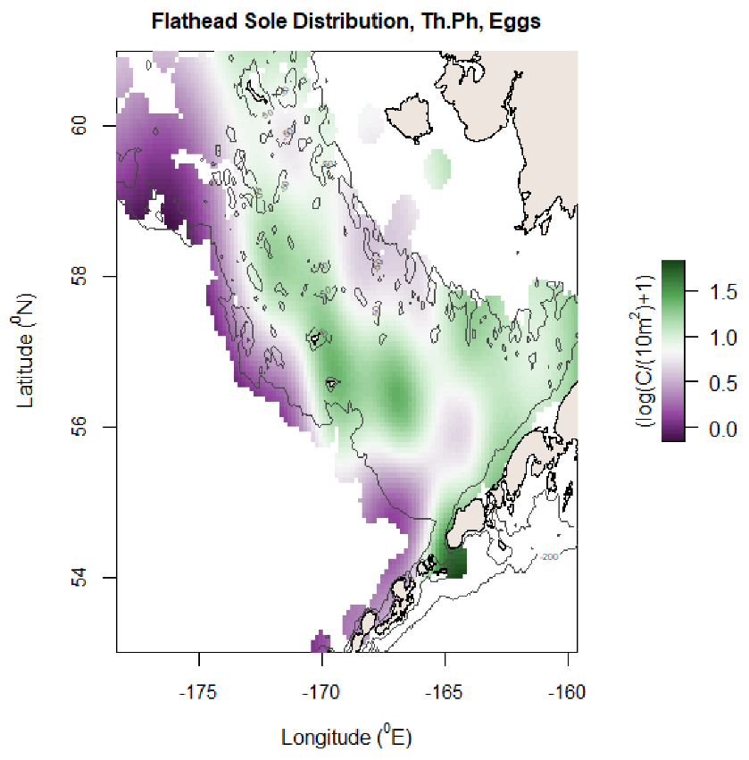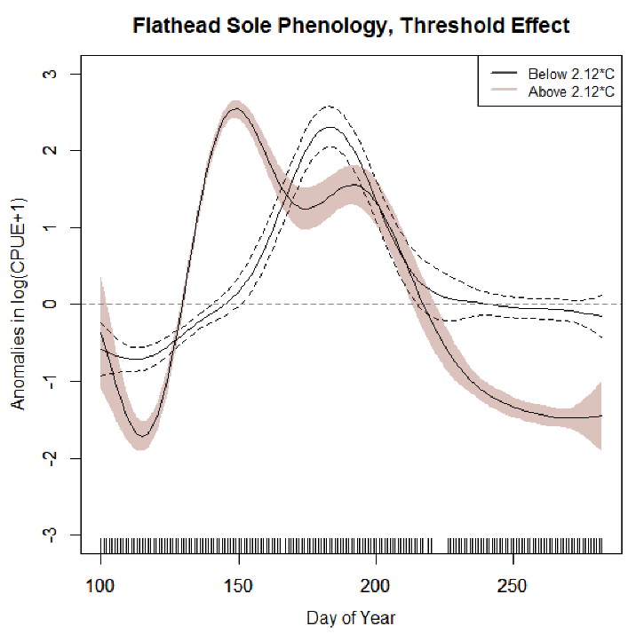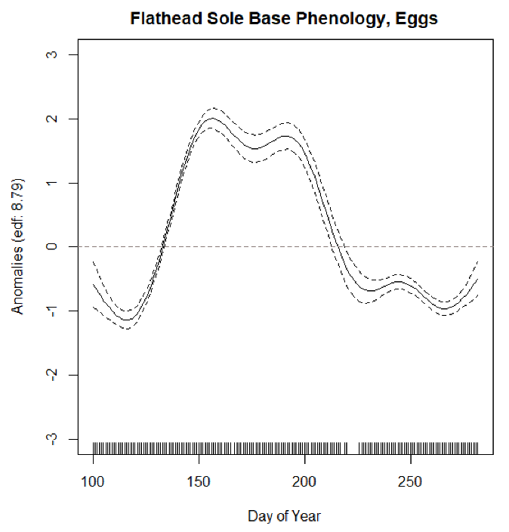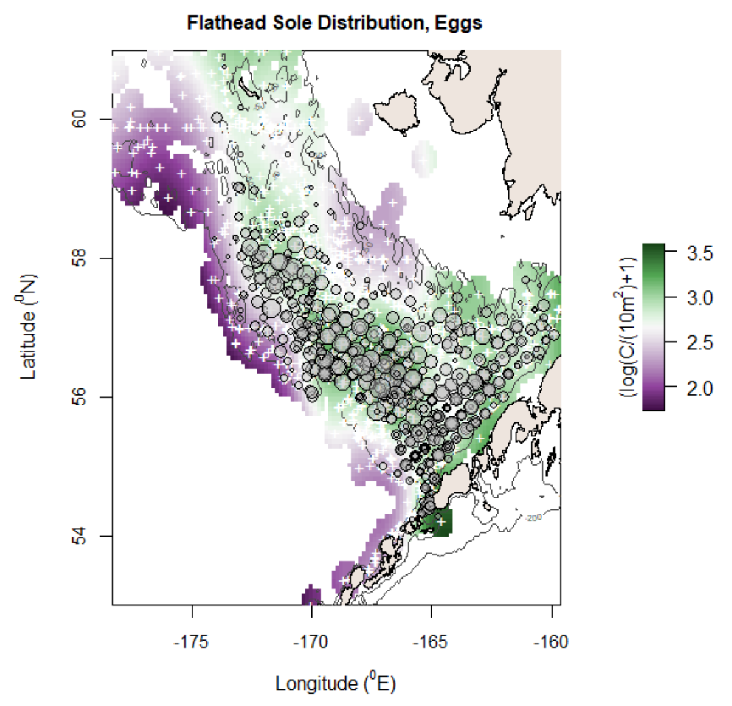

MSE reduction: 0.179, AIC reduction: 901.13, Deviance Explained: 76.2%

Deviance explained: 70.1%

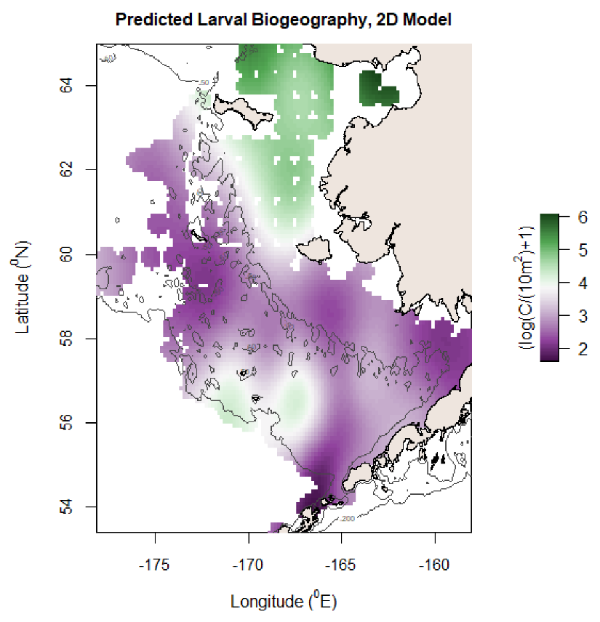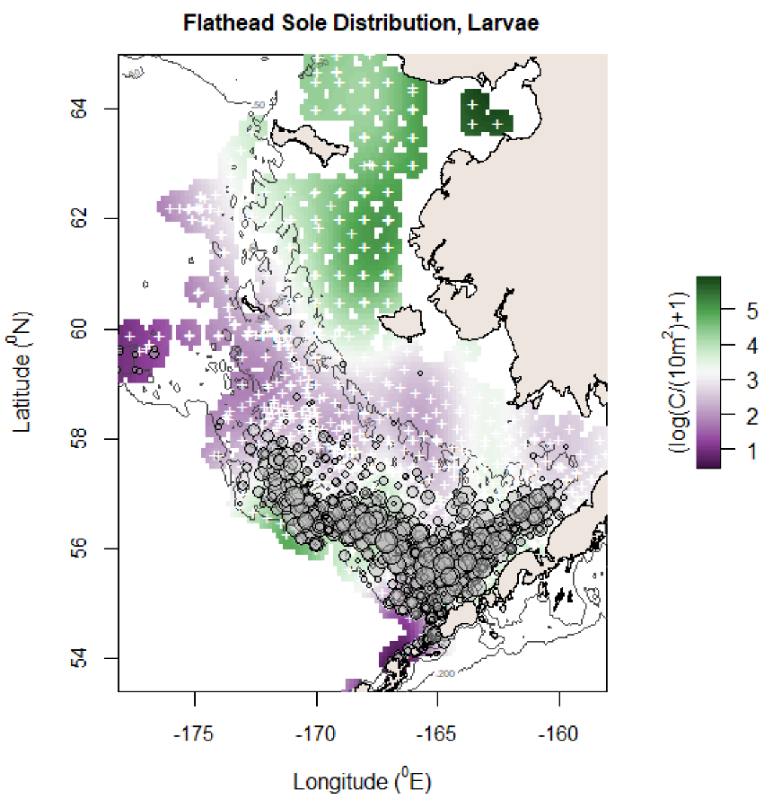

MSE reduction: 0.126, AIC reduction: 407.67, Deviance Explained: 72%

Deviance explained: 67%

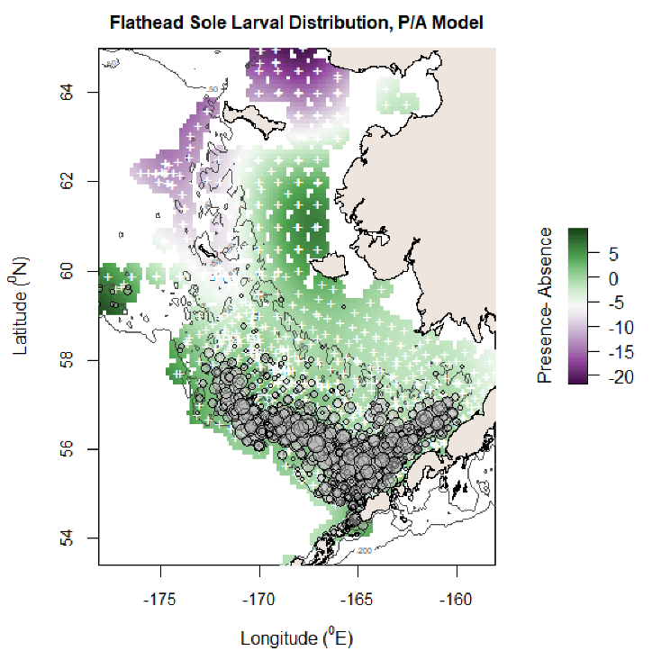

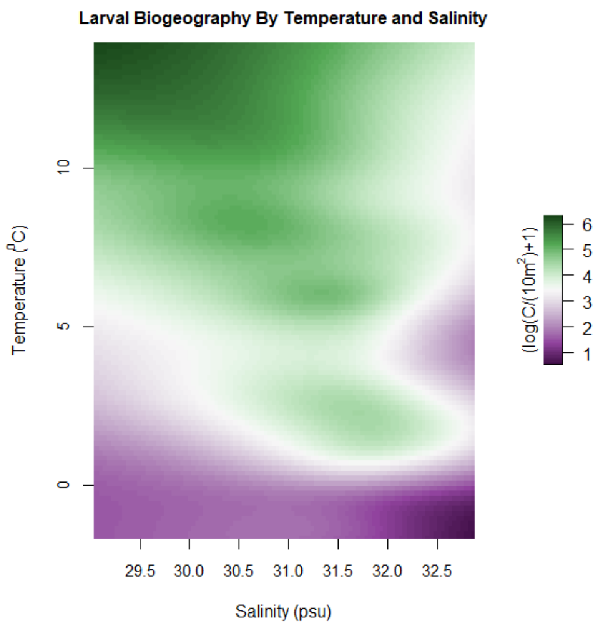

Deviance Explained: 61.1%

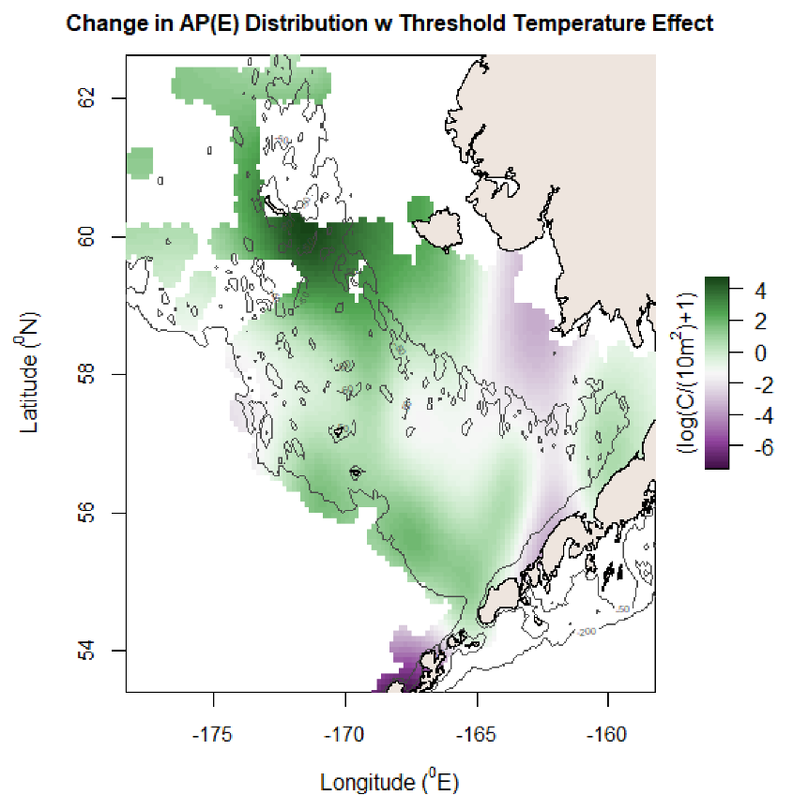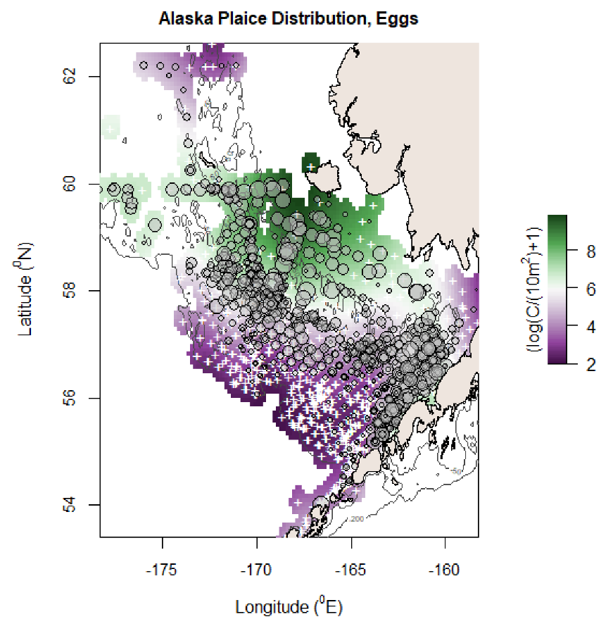

MSE reduction: 0.149, AIC reduction: 463.75, Deviance explained: 75%

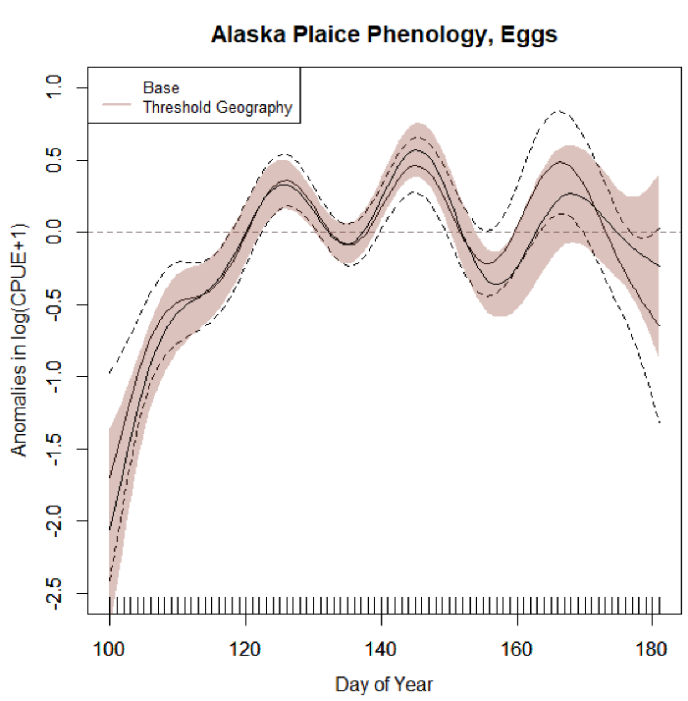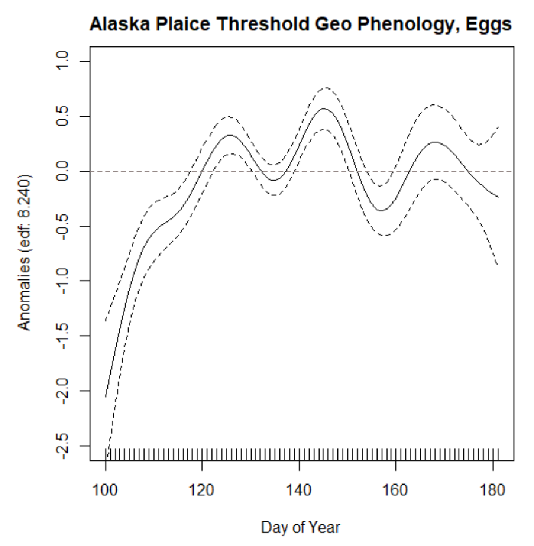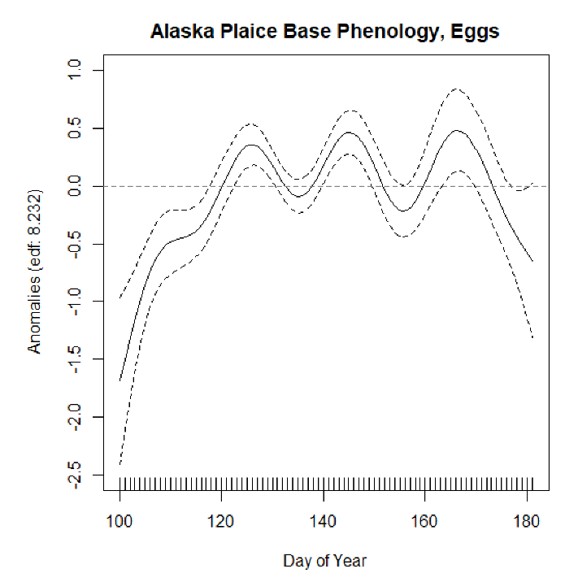

Deviance explained: 69.6%

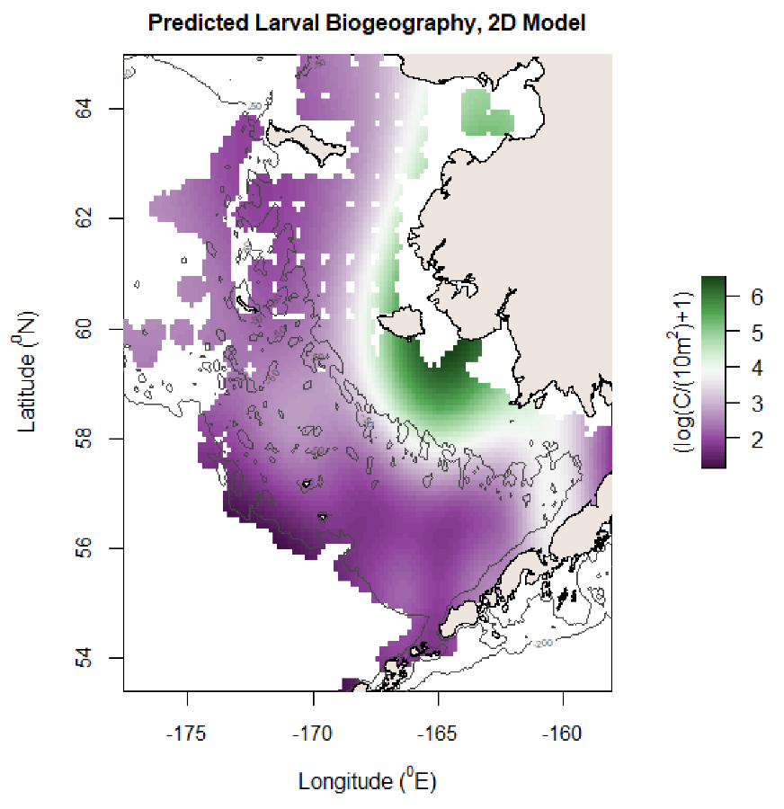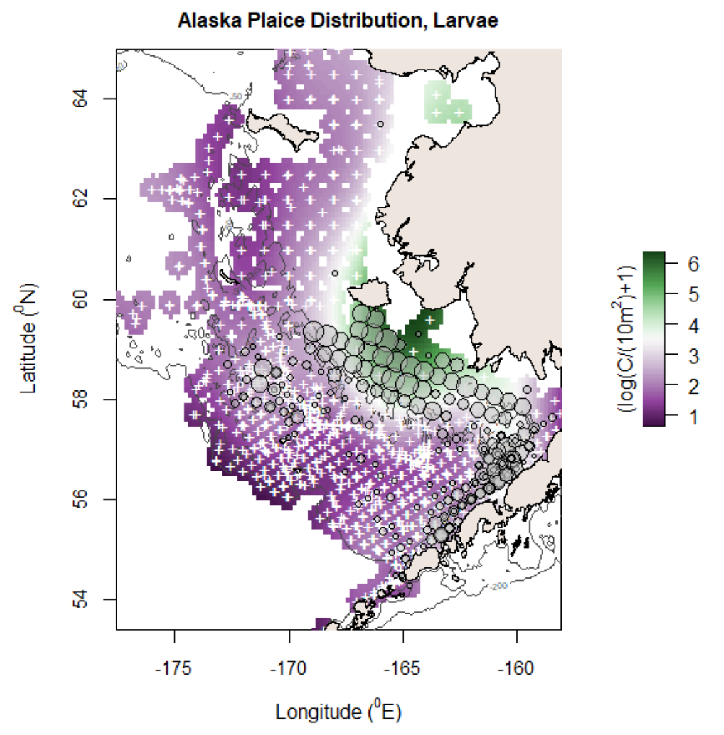

MSE reduction: 0.151, AIC reduction: 463.75, Deviance explained: 82.9%

Deviance Explained: 79.2%

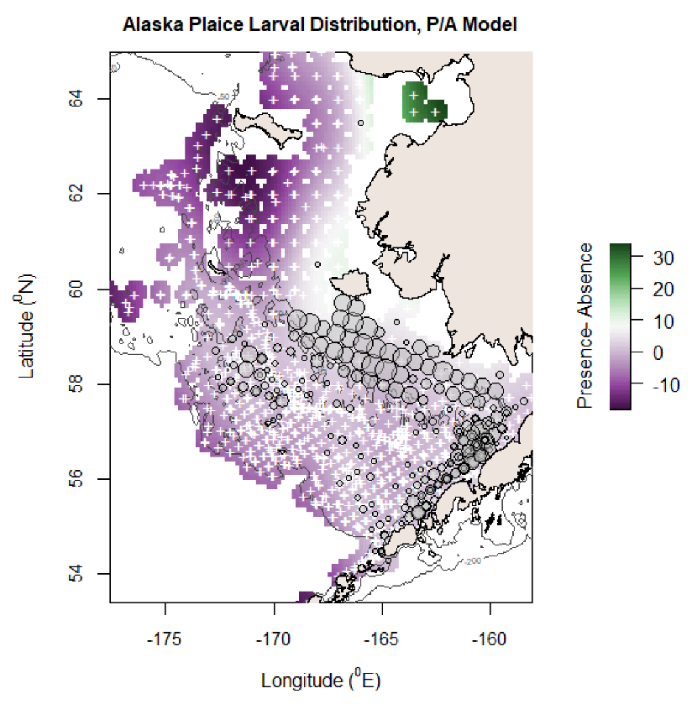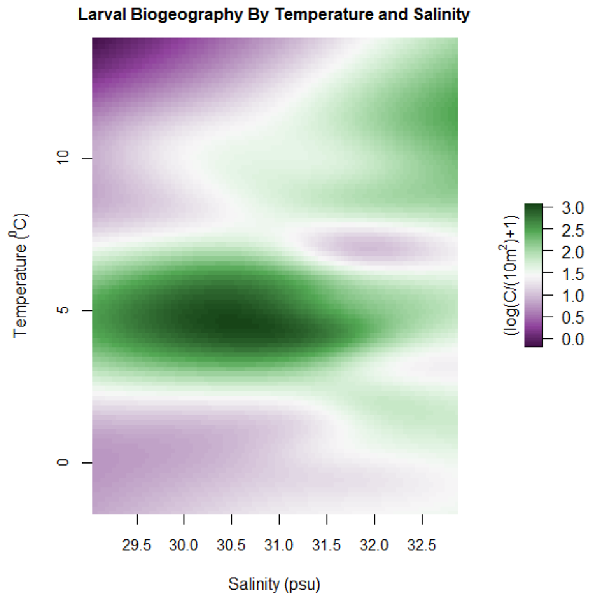

Additive temp model: Deviance explained 61.9%. Very close tie with 2D model (dev exp of 61.8%, same AIC)

MSE reduction: 0.133, AIC reduction: 591.2, Deviance explained: 58.1%

Deviance explained: 50.1%

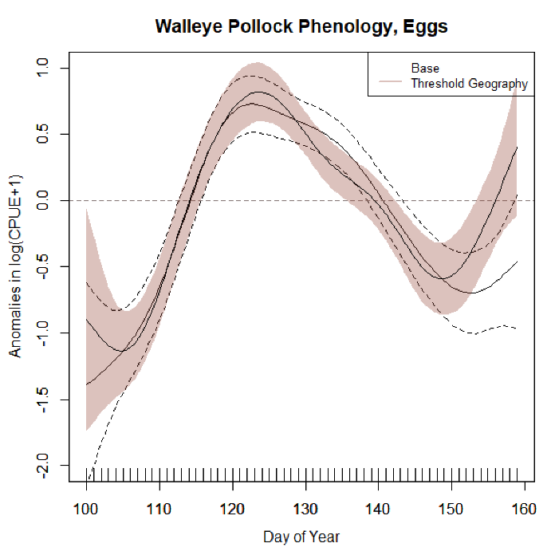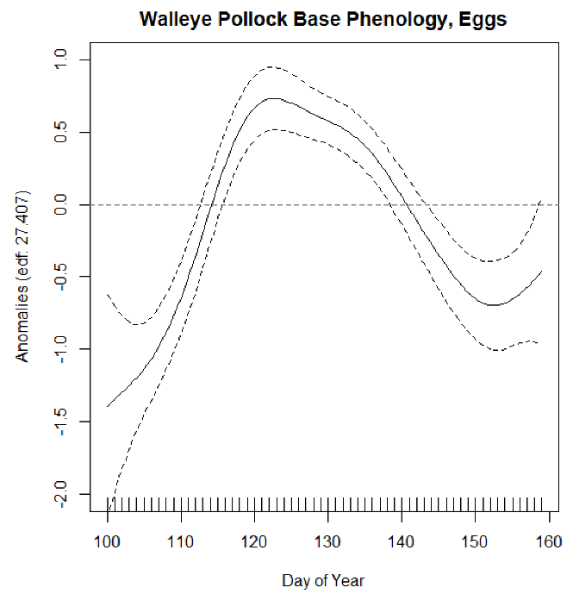

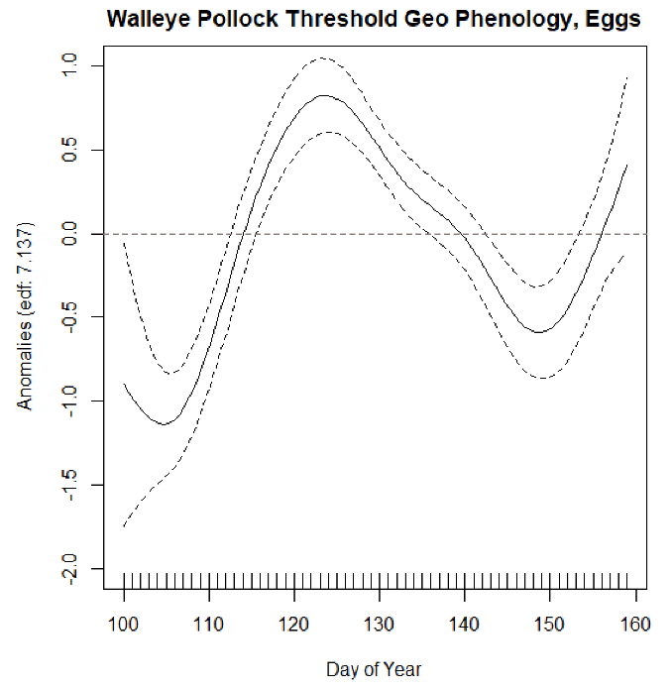

MSE reduction: 0.144, AIC reduction: 578.1, Deviance explained: 71.9%

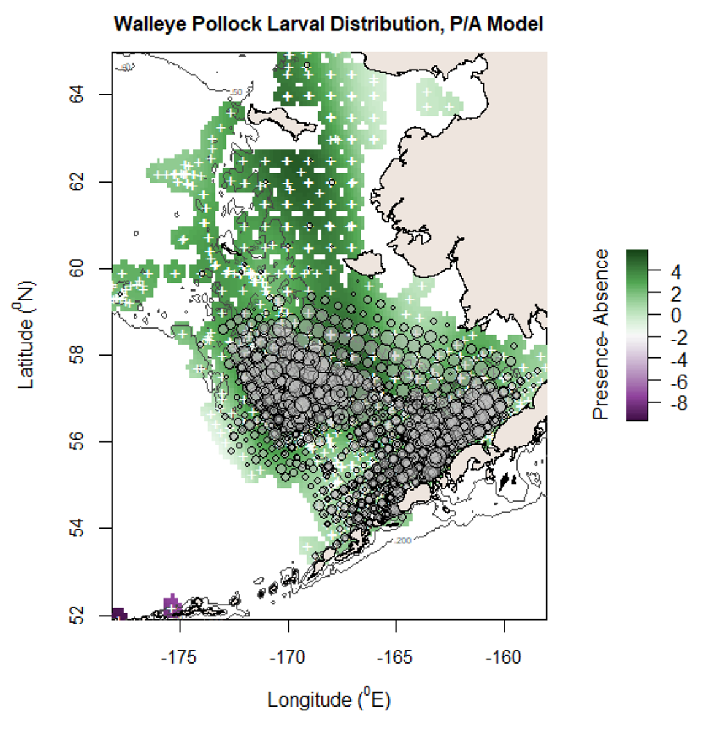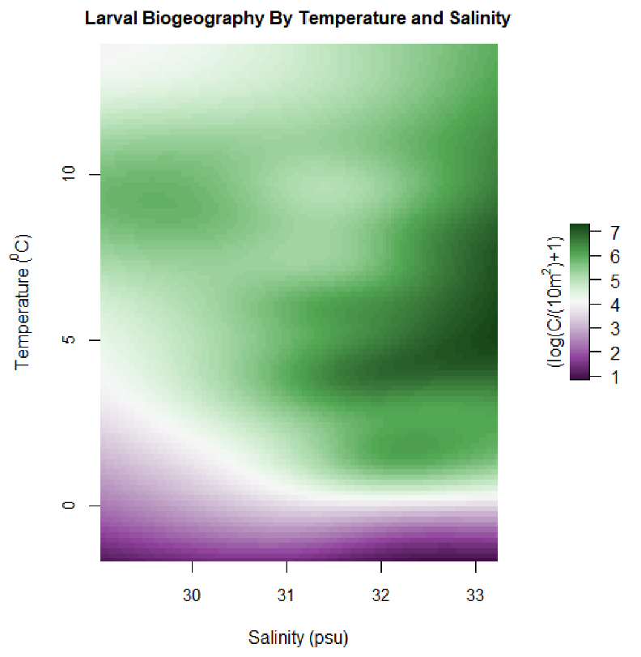

Deviance explained: 66%

Deviance explained: 60.7%

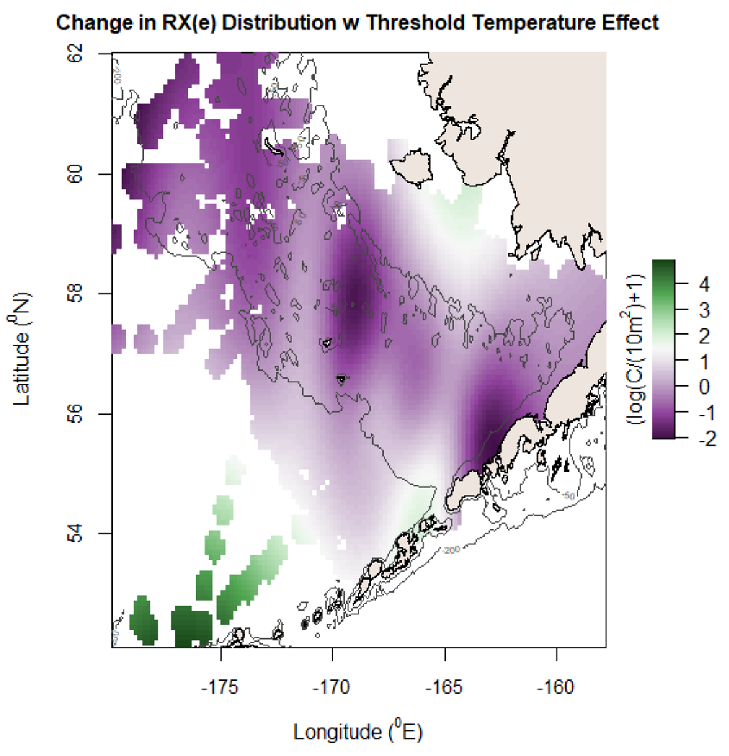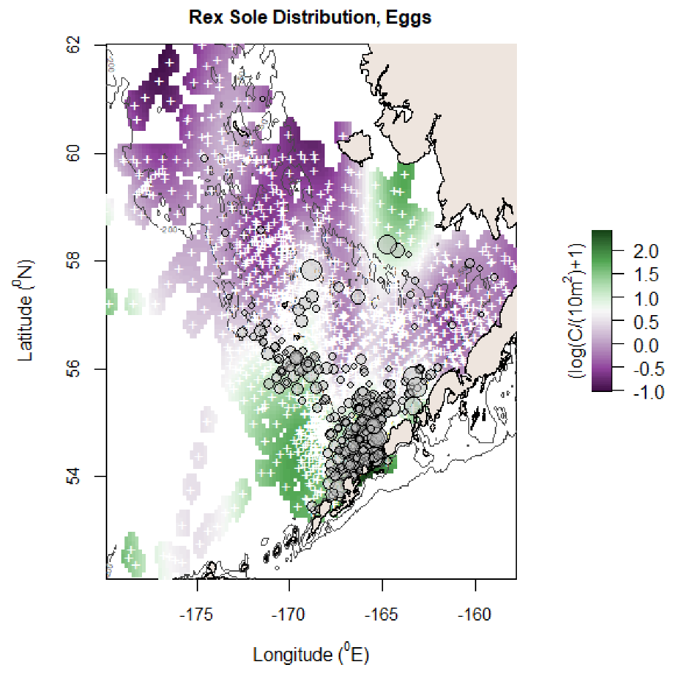

MSE reduction: 0.171, AIC reduction: 708.68, Deviance explained: 61.3%

1 Deviance explained: 51.9%

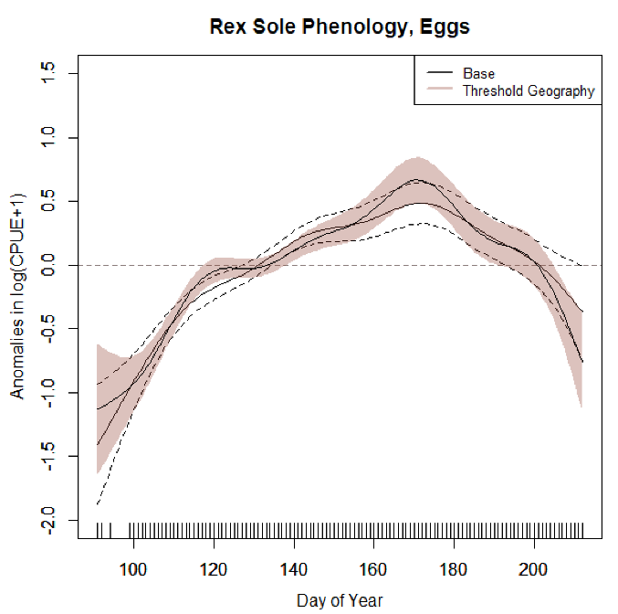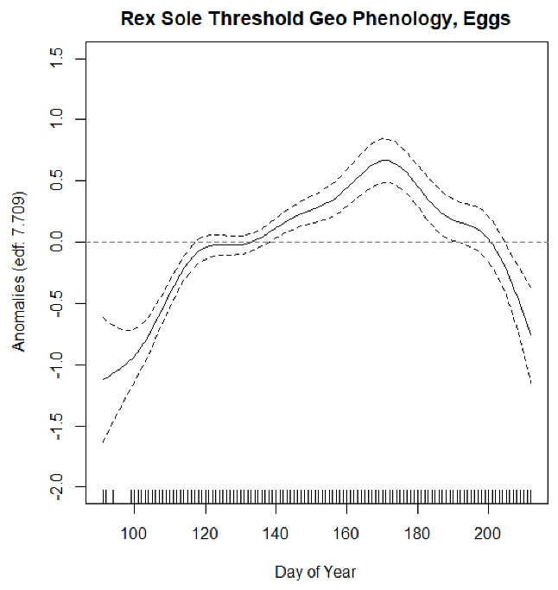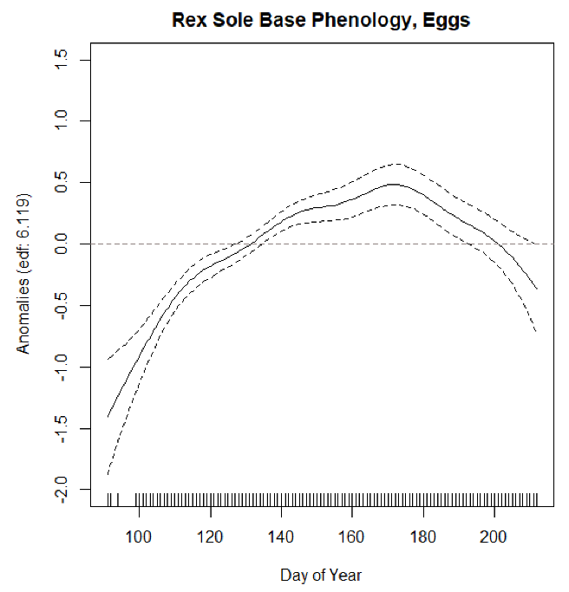

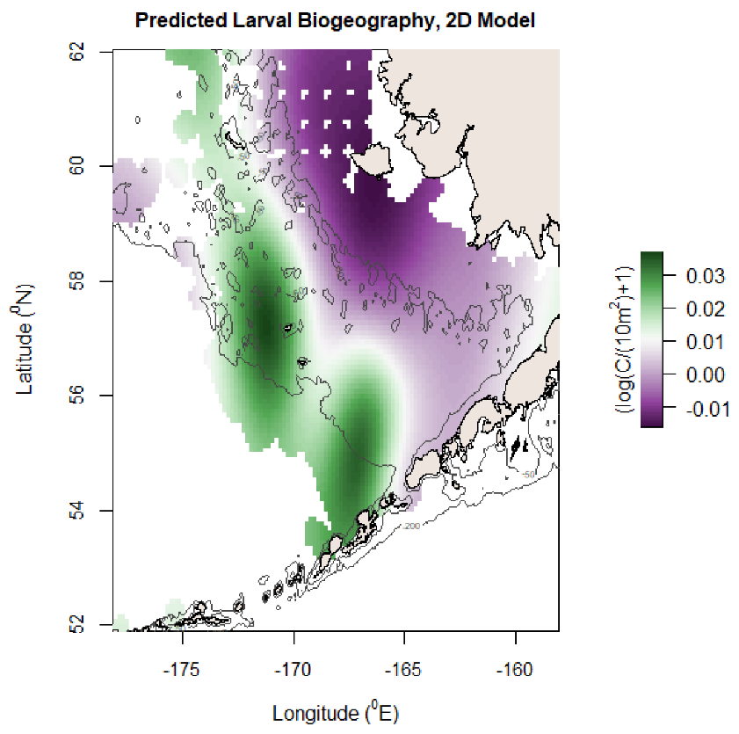

MSE reduction: 0.052, AIC reduction 113.18, Deviance explained: 17.3%

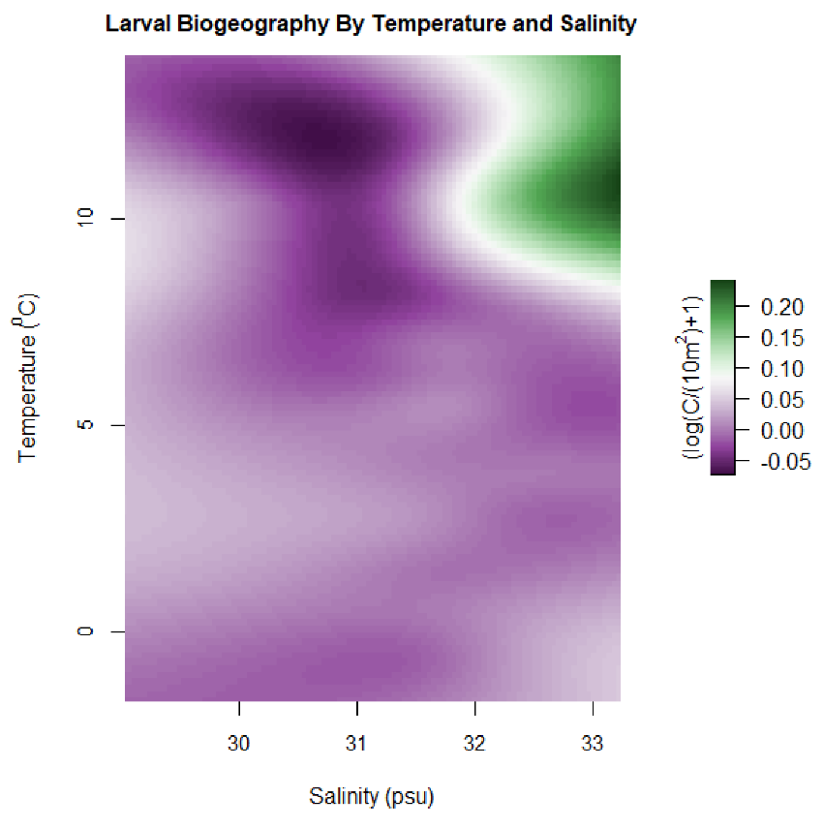

Deviance explained: 12.1%

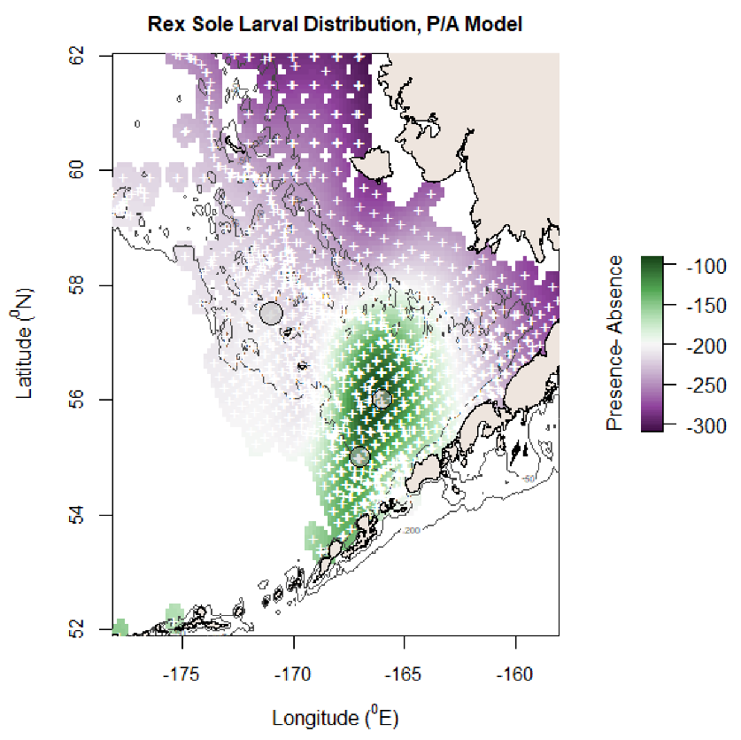

Deviance explained: 100% *obviously fishy....

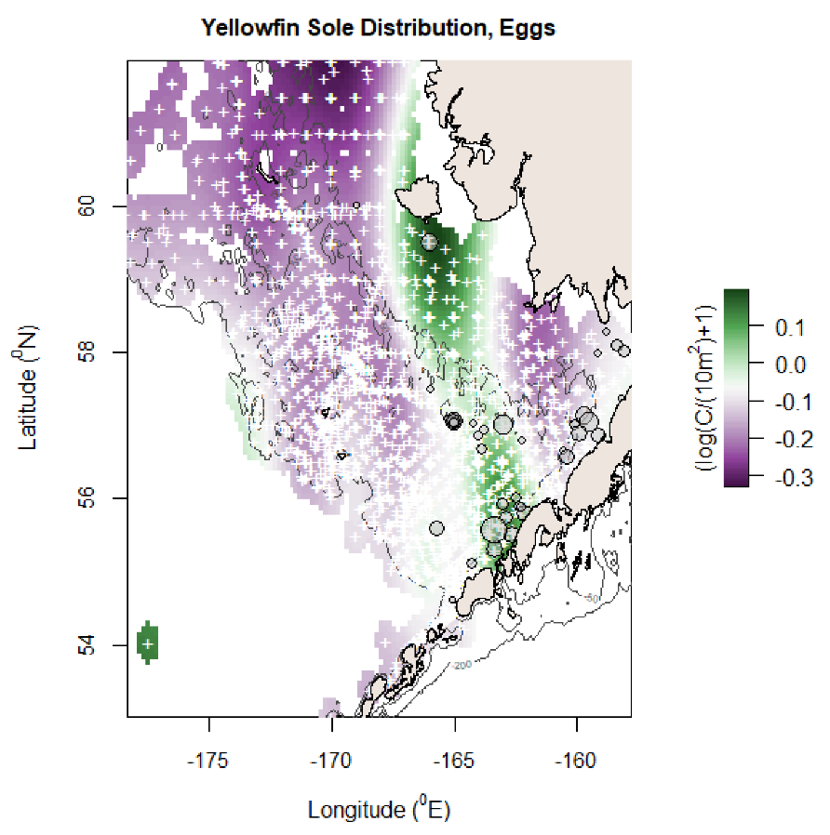

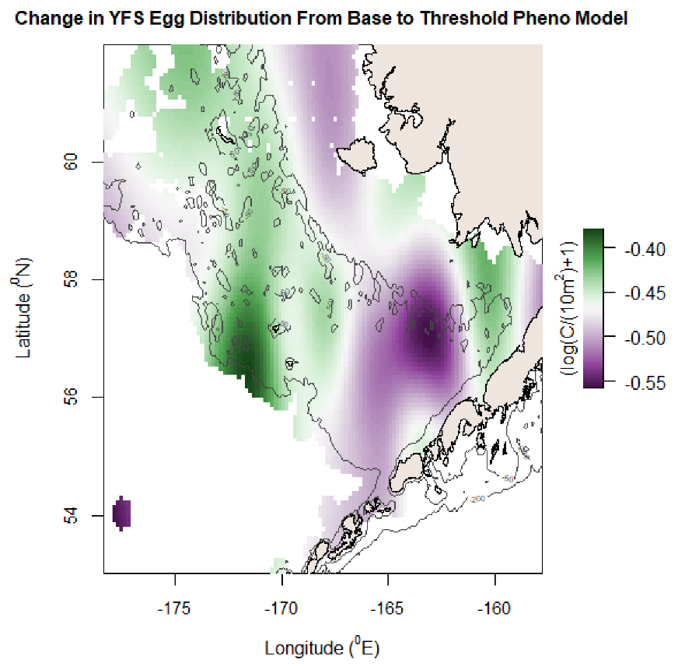

MSE reduction: 0.194, AIC reduction: 569.00, Deviance explained: 83.8%

Deviance explained: 64.6%

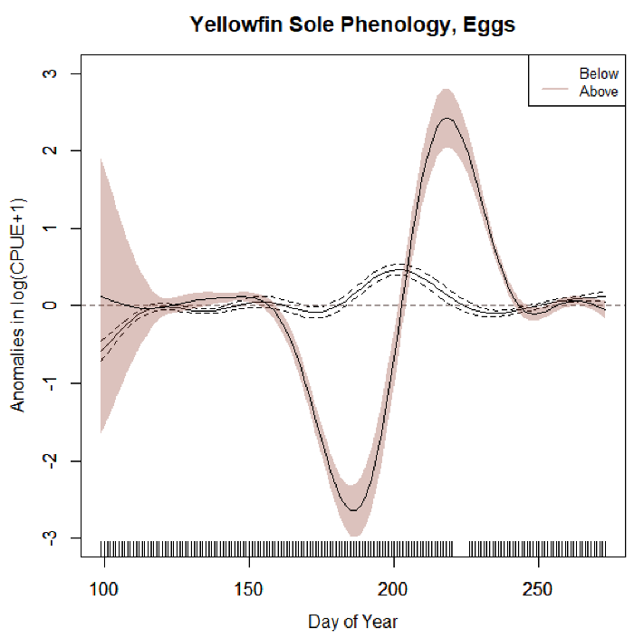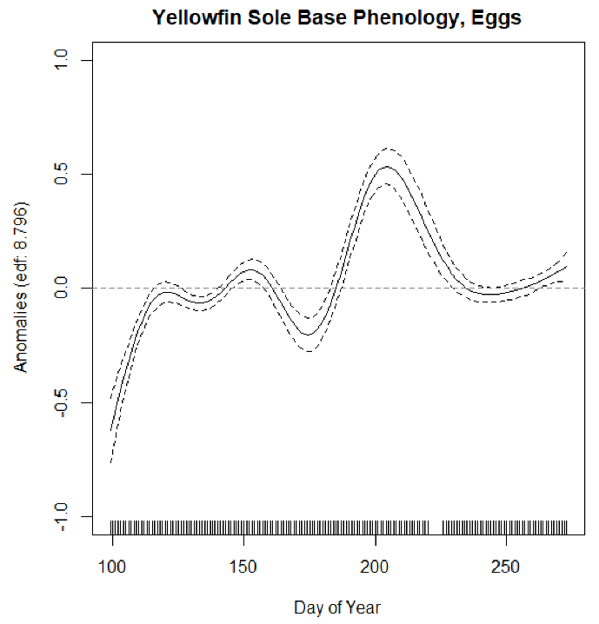

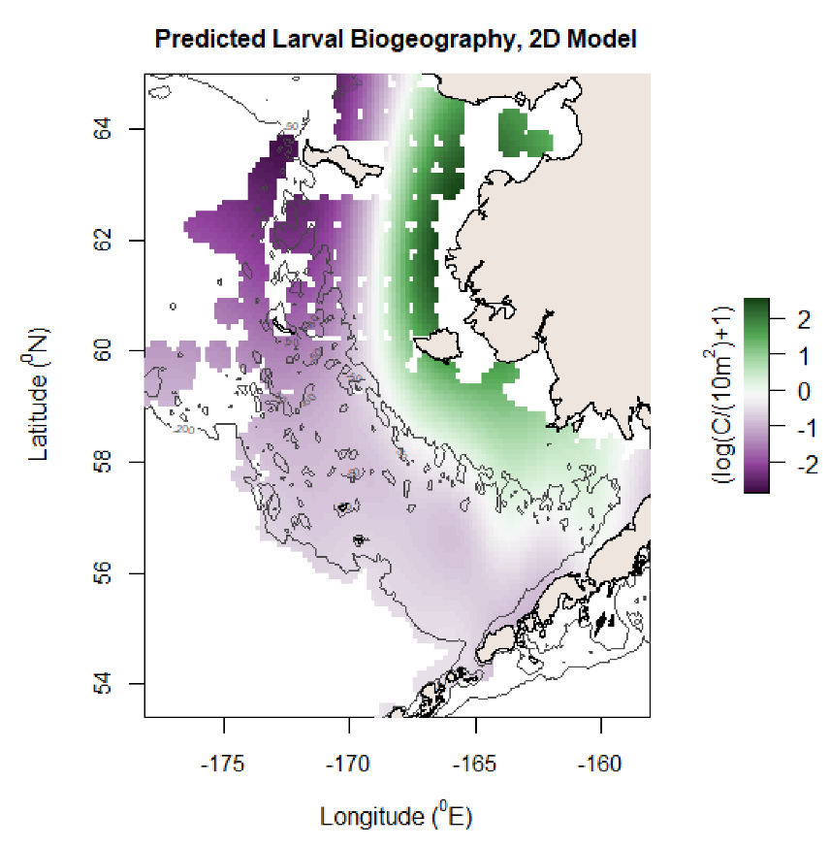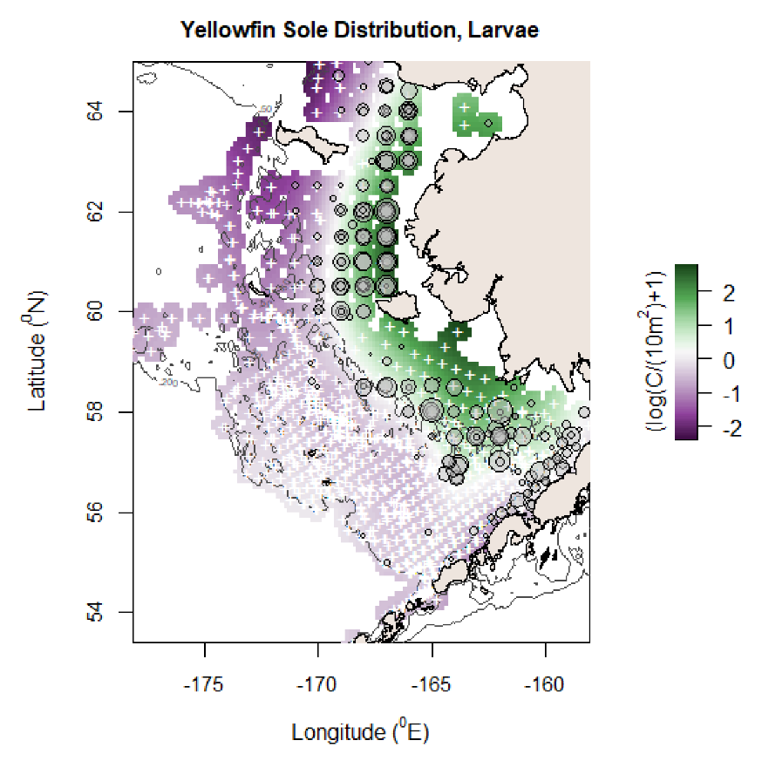

MSE reduction: 0.194, AIC reduction: 569.00, Deviance explained: 83.8%

Deviance explained: 79.2%

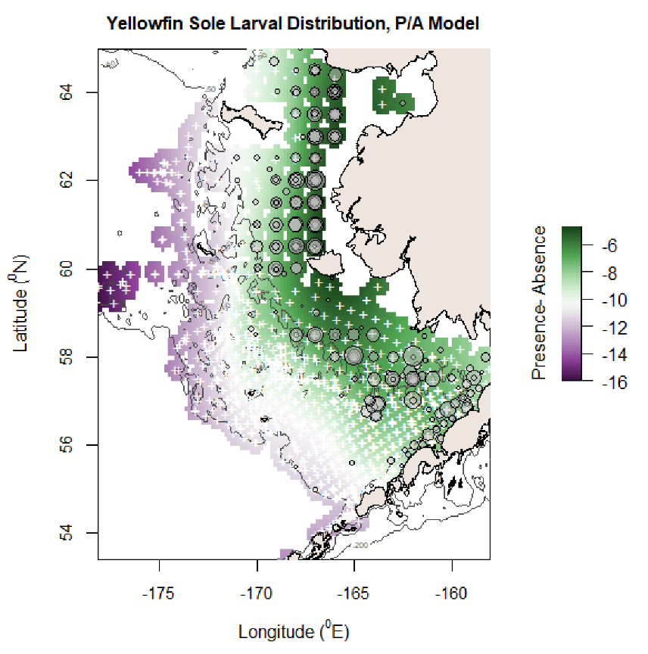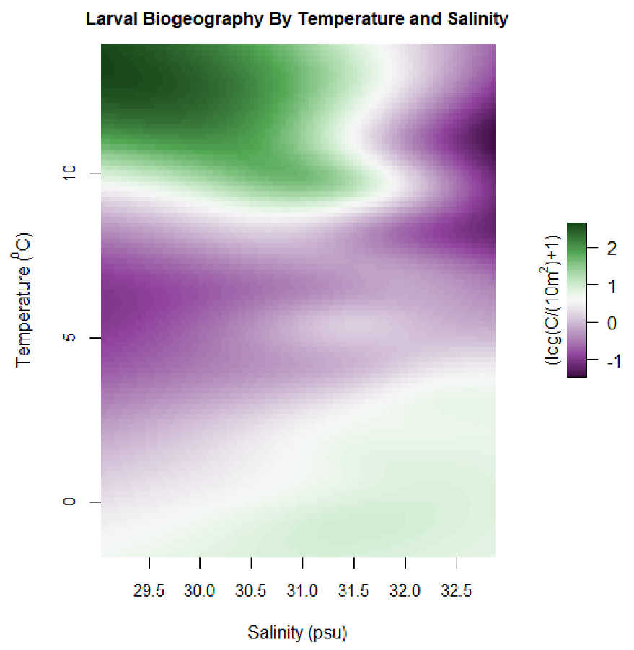

Deviance explained: 72%

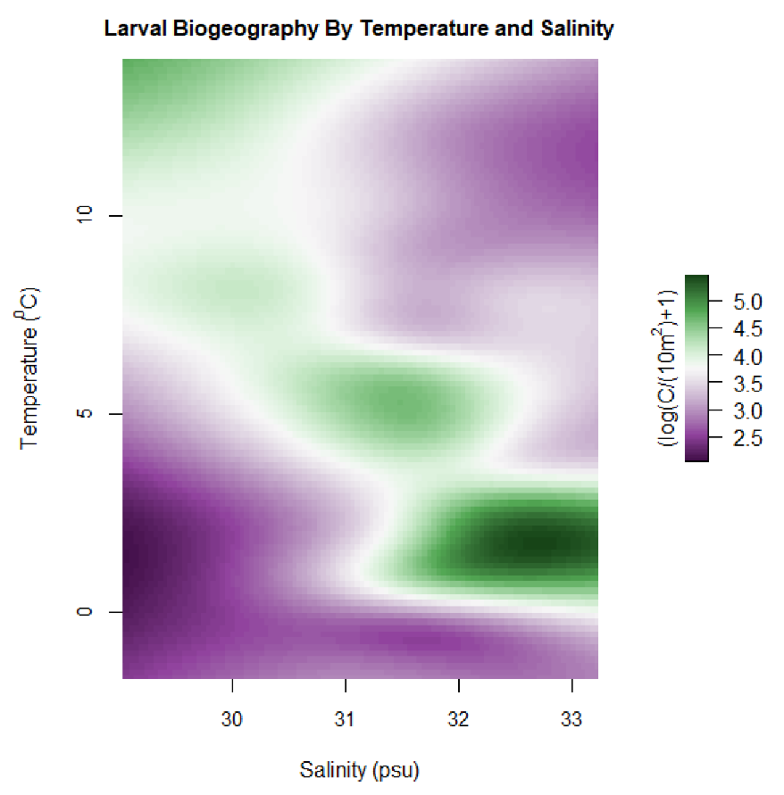

MSE reduction: 0.102, AIC reduction: 371.4, Deviance explained: 69.5%

Deviance explained: 65.2%

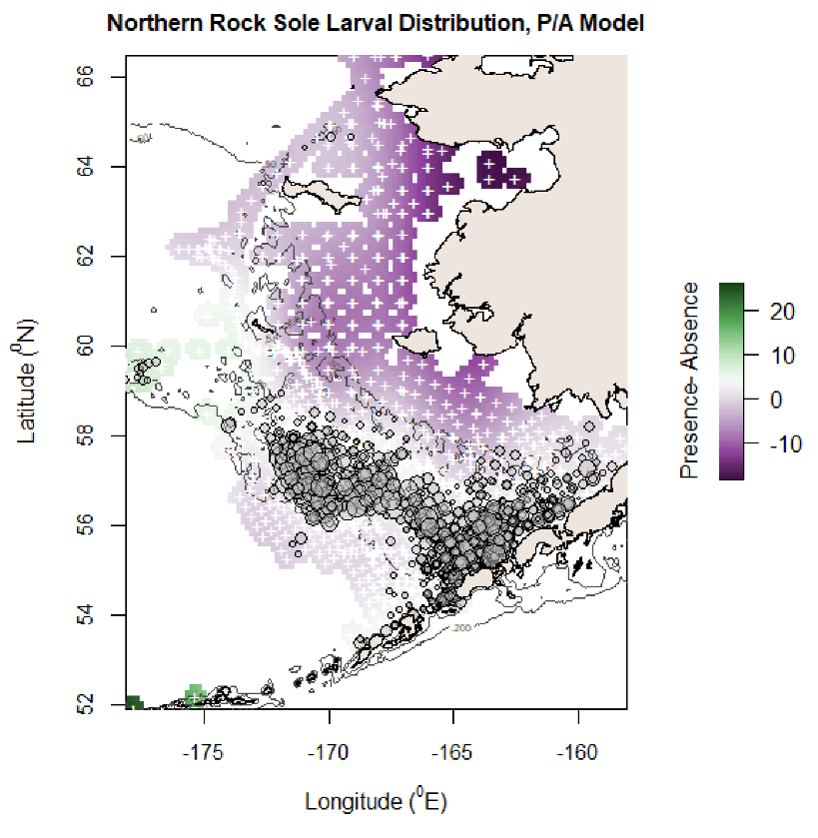

Deviance explained: 52.2%

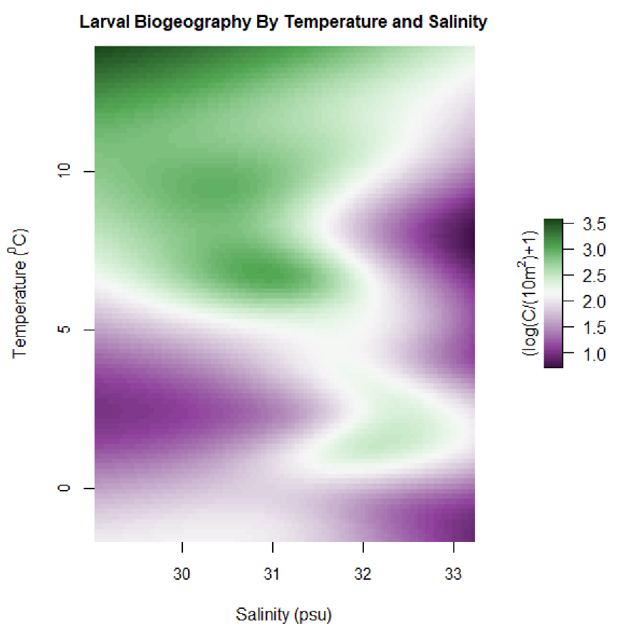

MSE reduction: 0.071, AIC reduction: 225.6, Deviance explained: 71.7%

Deviance explained: 69%

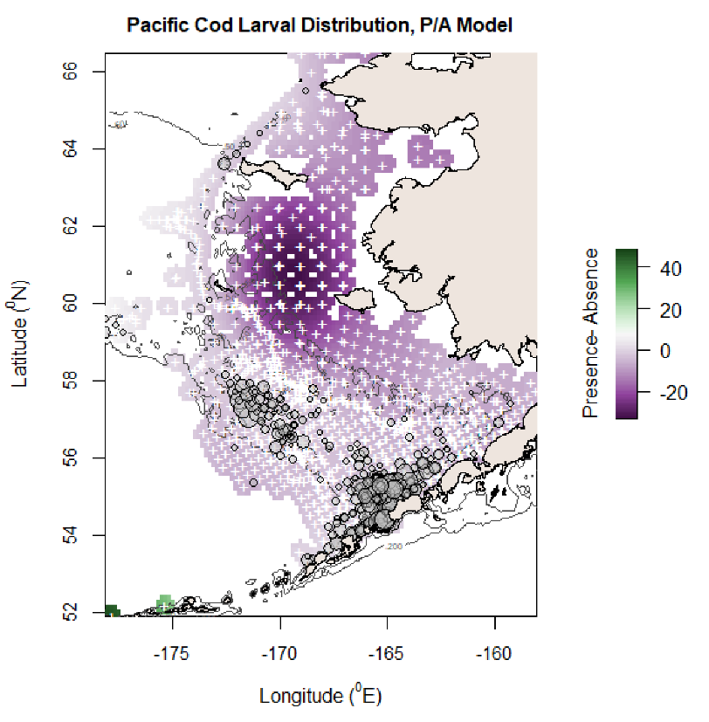

Deviance explained 52.6%

